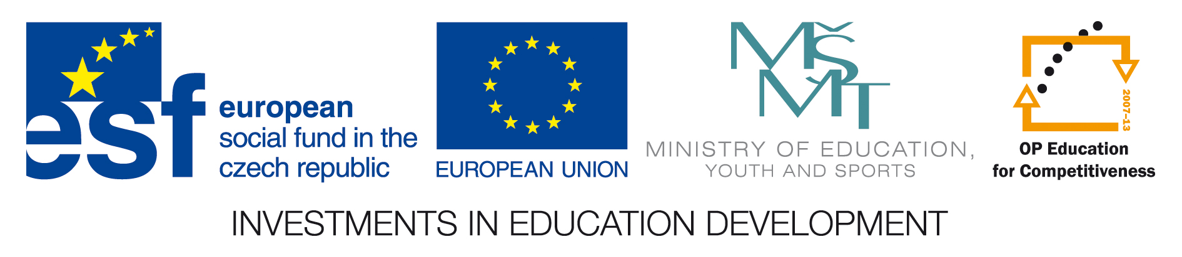

Department of Animal Nutrition and Forage Production

Faculty of Agronomy, Mendel University in Brno

hold International Animal Nutrition PhD Conference

NutriNET 2012

November 21 - 22, 2012
Mendel University in Brno

The conference is organized in the framework of the project number
CZ.1.07/2.3.00/20.0005

The symposium will be focused on research in animal nutrition and feed industry which has been done mainly on Universities and Research Institutes in the Czech Republic, Slovak Republic, Poland and Hungary.
The aim of the conference is to present results of PhD students research and to enable meeting of young researcher of this branch in central Europe.

Scientific Committee:
Prof. Ing. Ladislav Zeman, CSc.
Prof. Ing. Jiří Zelenka, CSc.
Prof. Ing. Zdeněk Mudřík, CSc.
Prof. MVDr. Vladimír Vajda, Ph.D.
Prof. Ing. Daniel Bíro, CSc.
Prof. MVDr. Ing. Pavel Suchý, CSc.
Prof. Ing. Eva Straková, Ph.D.
Prof. Ing. Bohuslav Čermák, CSc.

Organising Committee:

Assoc. prof. Ing. Martina Lichovníková, PhD., MENDELU
Ing. Eva Mrkvicová, MSc., PhD., MENDELU
The conference is without registration fees (proceedings, coffee, lunch, evening party are free for the participants)
All correspondence should be addressed to:
Eva Mrkvicova
Depatment of Animal Nutrition and Forage Production
Mendel University in Brno
Zemedelska 1
613 00 Brno
Czech Republic
e-mail: eva.mrkvicova@mendelu.cz or fajmon@mendelu.cz

Reservation of accommodation:
Participants of the conference make the reservation individually.
We recommend accommodation:
- hostel JAK, Kohoutova 3-11, 613 00 Brno, Tel.: 545 128 312, qreichov@mendelu.cz, http://skm.mendelu.cz/ (cca 15 min walking to Mendel University in Brno)
- in Hotel Avanti, Střední 61, 602 00 Brno, http://brno-hotel.hotelavanti.cz/, (cca 15 min by foot to Mendel University in Brno)
- in Hotel Slovan, Lidická 23, Brno, http://www.ubytovani-brno-slovan.az-hotel.eu/
- in Hotel Continental, Kounicova 6, Brno, http://www.continentalbrno.cz/
(cca 15 min by public traffic to Mendel University in Brno)

Information for authors

Full text max 5 pages A4 (include tables, pictures and figures) have to be in Microsoft Word 97 and higher (tables and figures black and white in Excel).
Format of page: up 2.0 cm, down 3 cm, left 3.2 cm, right 2.8 cm, head 1.25 cm, do not account the pages.
Format of text: font Times New Roman CE, 12, space 1,5.

title – FEEDING OF JAPANESE QUAILS
authors - NOVÁK, A.D. – SVOBODA, D.
department - Depatment of Animal Nutrition, Mendel University in Brno
Abstract (font Times New Roman CE, 12, space 1,5)
Material and Methods
Results and Discussion

Conclusion

Reference

The papers submit by e-mail: eva.mrkvicova@mendelu.cz
till July 20, 2012.

Registration form
(please return this form before June, 20, 2012)

NutriNET 2012
Mendel University in Brno, November 21 - 22, 2012

Title:
Full Name::

Company / Institution:

Address:

Country: | E – mail:
Tel.: | Fax:

I will present:
Oral presentations are preffered.
Oral presentation Poster No presentation

Authors:

Title of the paper or poster:

Institutions:

